# TECHNICAL RIDER VENUE DE GROTE POST 2019

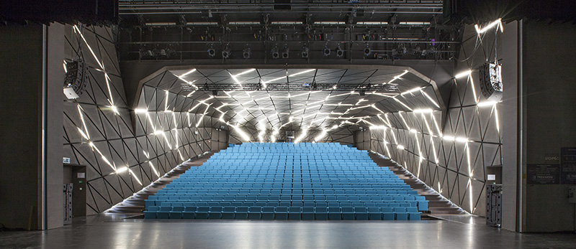

# LOCATION

Hendrikserruyslaan 18A

8400 Oostende

# CONTACT TECHNICAL CREW

|  |  |  |  |
| --- | --- | --- | --- |
| Sam serruys | Technical coördination and planning | +32477362335 | Sam.serruys@degrotepost.be |
| Jelle Van Meerbergen | Technical Coördination External Events | +32478619674 | Jelle.vanmeerbergen@degrotepost.be |
| Toon Soete | Stage manager | +32499268281 | Toon.soete@degrotepost.be |

# CONTACT PRODUCTION

|  |  |  |
| --- | --- | --- |
| Jasmien Withofs | +32485500317 | Jasmien.withofs@degrotepost.be |
| Lotte Magerman | +32485500317 | Lotte.magerman@degrotepost.be |

# CONTACT VENUE RENTAL

|  |  |  |  |
| --- | --- | --- | --- |
| Marion Buckens | Venue Rental Manager | +3259855605 | Marion.buckens@degrotepost.be |
| Anke Sabbe | Venue Rental Assistent | +3259855605 | Anke.sabbe@degrotepost.be |

# LAODING DOCK + ELEVATOR

* Load in and load out

Poststraat 8400 Oostende

**http://goo.gl/maps/pywLX**

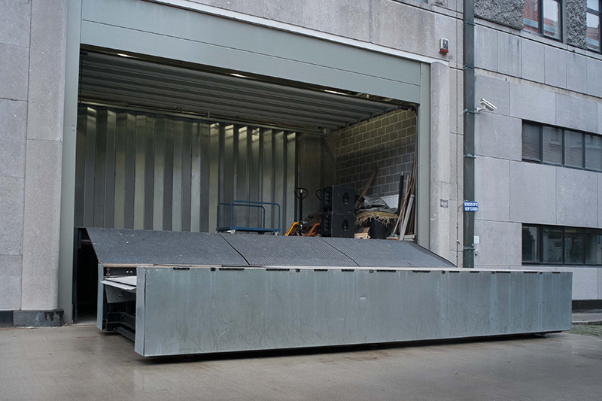

### /Volumes/data/C. AFDELINGEN/2. COMMUNICATIE/4. BEELDEN/1. FOTO'S/2. GEBOUW/1. FOTO'S PER RUIMTE/10 laadkade/Loading Dock/14.09.02 - Loading Dock - door Eric Stuckmann/Low Res/lokalen dgp 2-0003.jpg

Dimensions elevator: H 2,8m x W 2,5m x L 6,1m

# AUDITORIUM

Seats with orchestra pit: 431

Seats without orchestra pit: 347

Length: 20,7m

Width: 17,5m

Height: 3m to 10,7m

# FOH

In the back of the auditorium (no balcony) L 5m x W 1,8m x H 3m

# STAGE

Portal: W 14m x H 7,6m

Depth without proscenium: 8,5m

Depth with proscenium: 12m

Height: 14m

resilient floor

# PROSCENIUM

Contains of 3 parts

Total depth 3x95cm=2,85m

Hydraulic

# RIGGING

TREKWERK TNM

* Stage

27 automatic controlled Bars. L 19m

Lifting height 14m

Lifting capacity 300kg

Max Speed 0,8m/s

* Above proscenium

11 automatic controlled Bars. L 16m

Lifting height 9,6m

Lifting capacity 300kg

Max Speed 0,8m/s

* Rigging Material

|  |  |
| --- | --- |
| VMB wind-up 7,80m | 4 |
| Manfroto wind-up 6m | 8 |
| Manfroto T-Bar | 8 |
| Reutlinger | 10 |
| sofsteels | 14 |
| Steels 3m | 6 |
| Steels 4m | 8 |
| Doughty clamb | 15 |
| Shackle | 50 |

* Mobile stage elements

|  |  |  |
| --- | --- | --- |
| Praktikabel 2x1m | Adjustable level | 4 |

../../../../../Downloads/GROTE_POST_1.pdf

## ../../../../../Downloads/GROTE_POST_2.pdf

# ../../../../../Downloads/GROTE_POST_3.pdf

# POWER

3 phase electric power 400V

Connections: 125 Amp, 63 Amp, 32 Amp, 16 Amp

# LIGHT

* 240ch ADB Dimmer/switch 3KW
* 72 Floor connections
* 24 connections in bridge for front lightning
* Controllers: ADB Freedom and Chamsys mq60 + Wing
* Fixtures:

|  |  |  |  |
| --- | --- | --- | --- |
| ADB | Profile | 2 kw | 12 |
| ADB | Profile | Shortnose 1,2 kw | 12 |
| ADB | profile | Longnose 1,2 kw | 12 |
| ADB | PC | 2 kw | 12 |
| ADB | PC | 1,2 kw | 32 |
| ADB | Fresnell | 1,2kw | 12 |
| ADB | ACP | 1kw | 12 |
| ADB | ALC 4 | led | 6 |
| PAR Thomas | PAR | 1kw | 30 |
| Robe | Actor 6 | Ledwash | 16 |

# SOUND

* FOH RENKUS HEINZ VARIA

|  |  |  |  |
| --- | --- | --- | --- |
| Flown system | 2xVA101-7/6-52R | 1X VA101-15/69-52R | 1xVA101-22/9-52R |
| Stacked system | 1xVA101-22/9-52R | 2xVA15S-5R |  |
| Center flown | 1xVA101-22/69-52R | 1x101-22/912-52R |  |
| Front Fill | L-acoustic x8 |  |  |

* Mixers

|  |  |  |
| --- | --- | --- |
| D-live | C2500 | 48 inputs 32 outputs |
| Midas | venice | 24 inputs 8 outputs |

* Monitors

|  |  |  |
| --- | --- | --- |
| Martin | LE 1200 | 8 |

* Amps

|  |  |  |
| --- | --- | --- |
| Powersoft | M30D DSP eth 2x 1500w/4ohm | 4 |

* Communication

|  |  |  |
| --- | --- | --- |
| ASL | 2CH headstation PRO | 1 |
| ASL | Single beltpack PRO | 4 |
| ASL | Dual Beltpack PRO | 2 |

* Microphones

|  |  |  |
| --- | --- | --- |
| shure | Sm58 | 6 |
| shure | Beta 58 | 5 |
| Audio Technica | AE 3000 | 2 |
| Audio Technica | AE5400 | 1 |
| DPA | Sc4098 | 1 |
| DPA | 4099 LO | 2 |
| DPA | 4099 HI | 1 |
| Neumann | Km184 | 2 |
| shertler | pianoset | 1 |
| Shoeps | Mst c6 | 1 |
| Shure | Sm 57 | 4 |
| Shure | Beta 57 | 2 |
| shure | Beta 91 | 1 |
| shure | Beta 52 | 1 |
| AKG | D112 | 1 |
| EV | RE20 | 1 |

* DI

|  |  |
| --- | --- |
| BSS AR-133 | 3 |
| Radial J48 | 8 |
| Radial Pro DI | 4 |
| Radial JPC | 2 |
| Radial twin iso | 1 |

* Stands

|  |  |
| --- | --- |
| K&M long boom | 16 |
| K&M short boom | 7 |
| K&m Bassdrum stand | 1 |
| K&M Table stand | 8 |

# VIDEO

* Panasonic PT-EX12K (XGA, 4000:1, 13000 ansi lumen)
* Repeater:

|  |  |  |  |
| --- | --- | --- | --- |
| beamer | Panasonic PT-EX12K(standard lens) | (XGA, 4000:1, 13000 ansi lumen) | 1 |
| repeater | HDMI (cat 5) |  | 1 |
|  | VGA (cat 5) |  | 1 |
| convertor | VGA to HDMI |  | 1 |
|  | MINI DISPLAY PORT to HDMI/VGA/DVI |  | 2 |
|  | MINI DISPLAYPORT to VGA |  | 1 |
|  | BM HDMI-SDI/SDI-HMI |  | 1 |
| screen | Projectonscreen 14x7 |  | 2 |

# SMOKE

|  |  |  |
| --- | --- | --- |
| Hazer | Swefog XEON II intellahazer | 1 |
| Antari | Z-3000II | 1 |